IST 363

Lab 04

This Lab Covers
- Tailwind

Lab Corrections
- If you didn’t get a perfect score on the SASS page in lab 3, make corrections and turn in your url for this part.

warmup
You may not use artificial intelligence to answer the questions below.

  - How do utility classes in Tailwind replace writing custom CSS styles?
  - What Tailwind utility classes would you use to center a div both vertically and horizontally?
  - How can you define a custom color in Tailwind (some investigation will be needed for this question)?

SASS Page
- Tailwind Page
You will be creating a news site home page. I’ve pasted the desktop and mobile view images below. You don’t have to make this look good at tablet size unless you want to. There’s a .zip file of the processed images up in Blackboard. Match my colors by using the Tailwind reference. My blue is an indigo. The large image and footer are a version of gray.
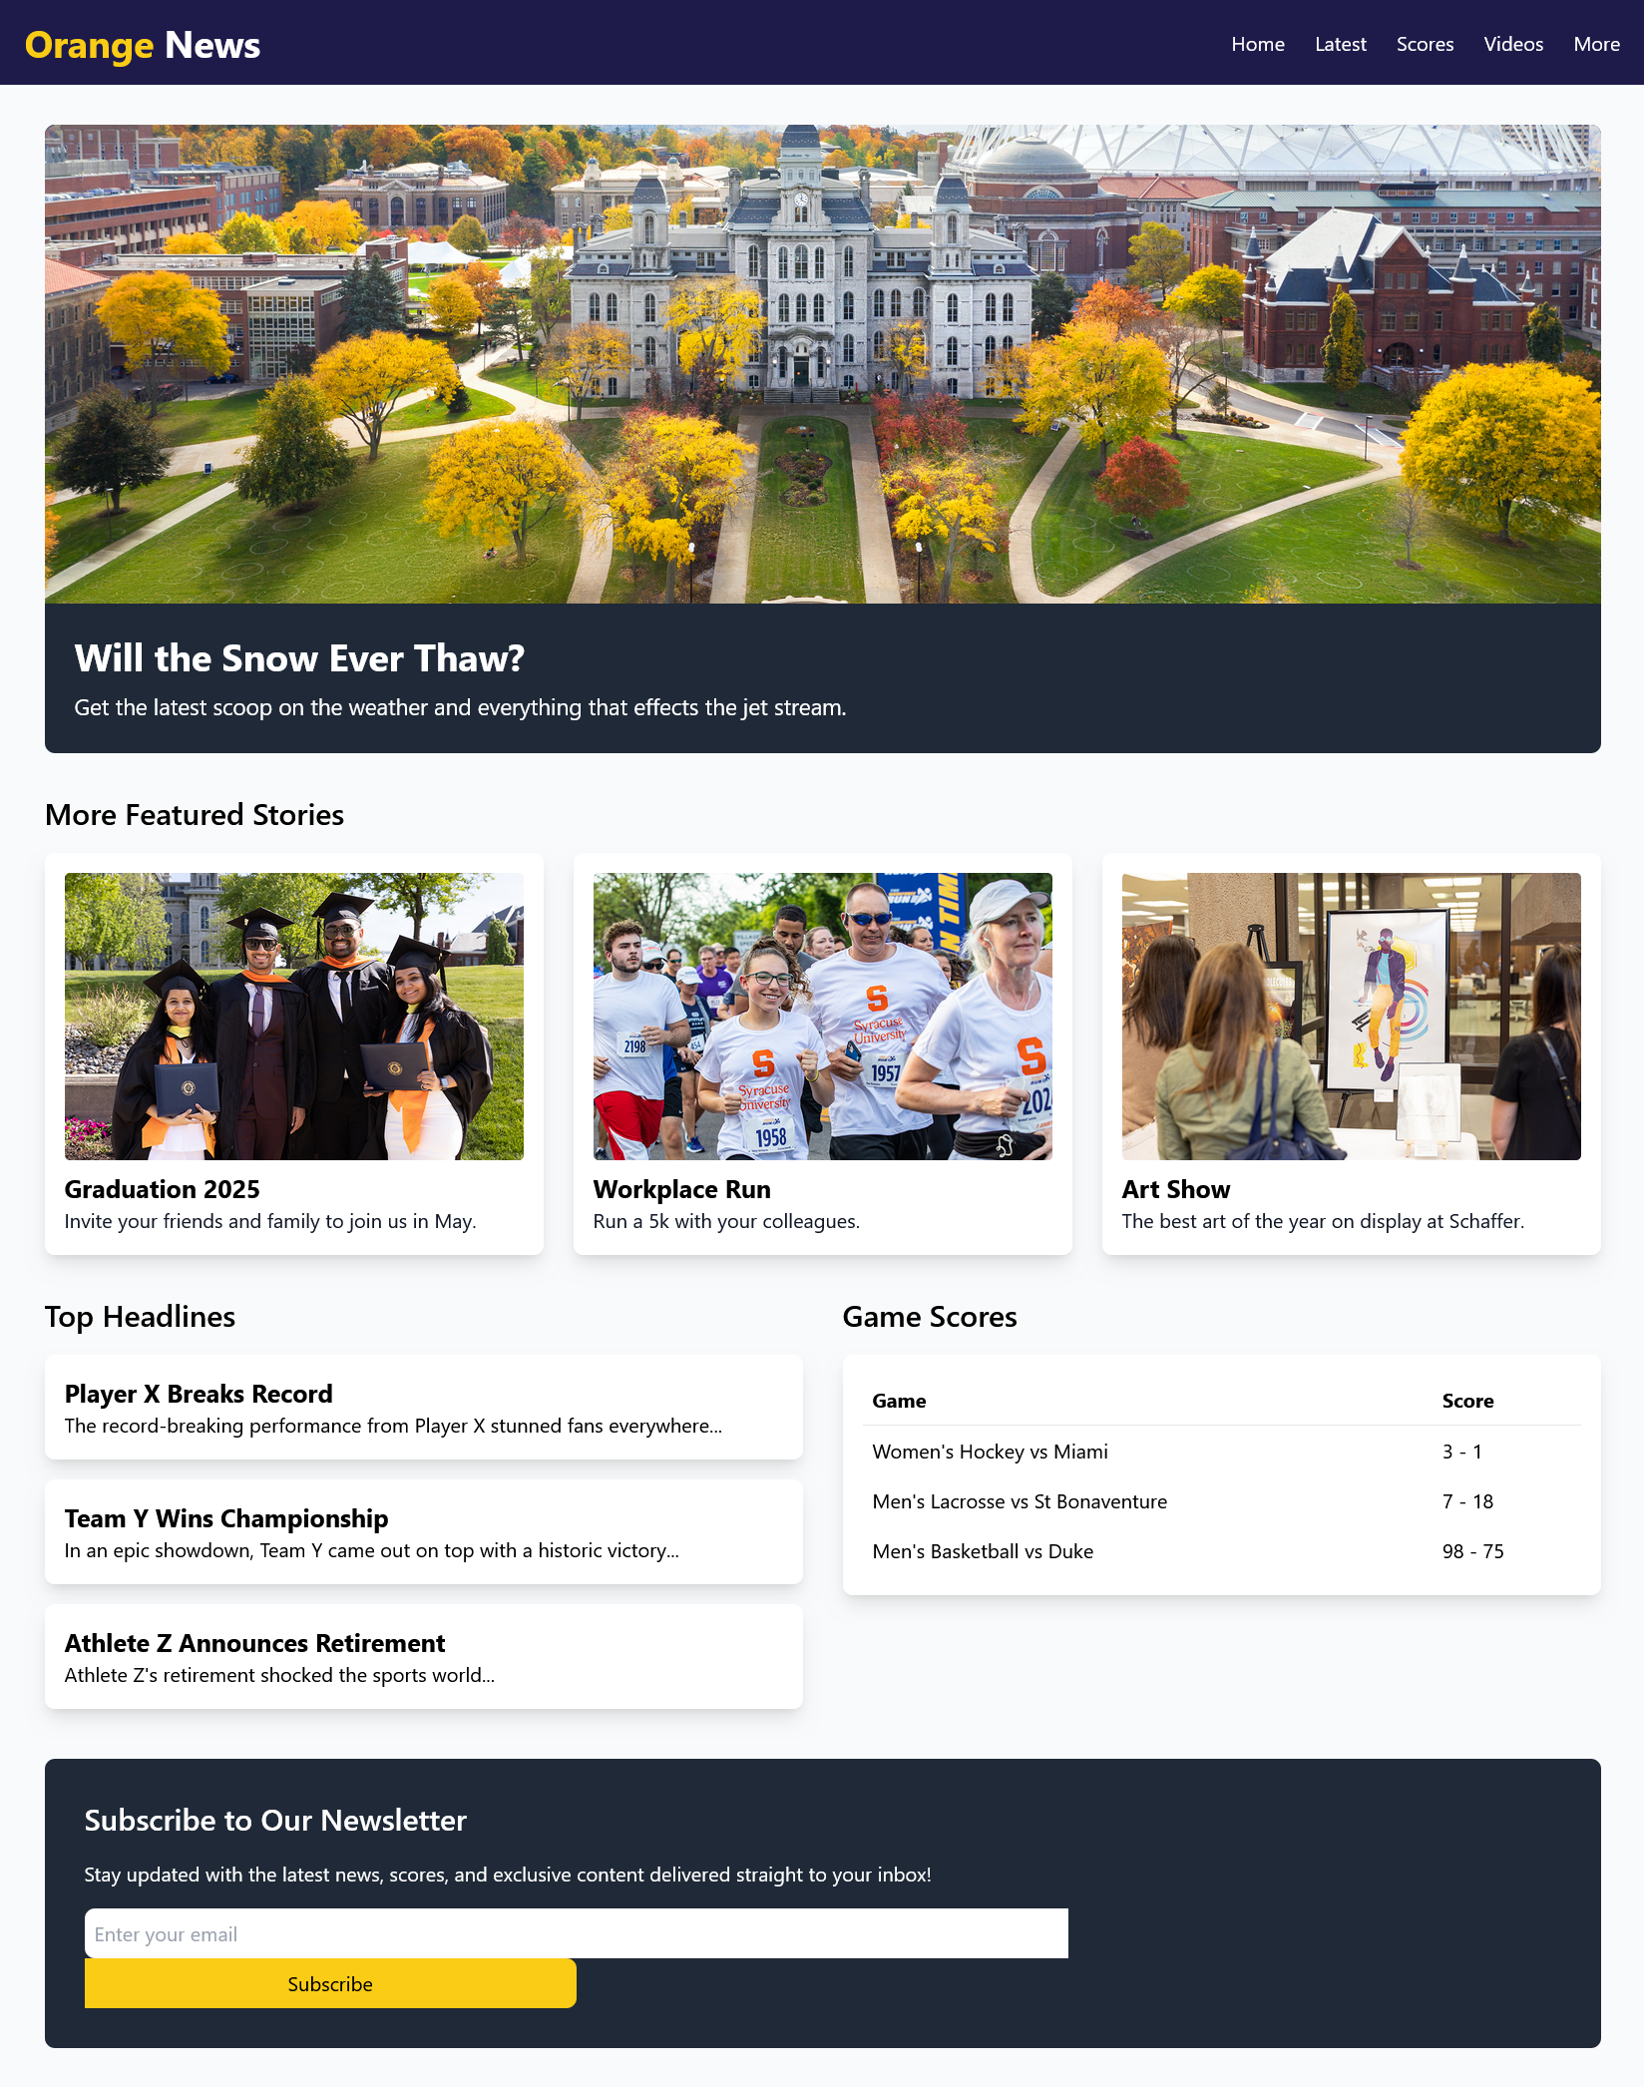 | 

What to hand in
Note that if any URL doesn’t work for me, you will get a zero on this part. Ensure github.io is part of the URL in the address bar. If it’s not, you haven’t given me the correct link.
- For the corrections hand in the URL of the corrected page.
- For the review questions, paste your answers into the template provided in Blackboard.
- For the Tailwind page, hand in the URL
Use the answer template!

